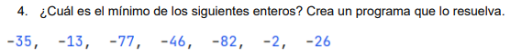
public static void main(String[] args) {
int[] array = {-35, -13, -77, -46, -82, -2, -26};
int min = array[0];
for (int i = 0; i < array.length; i++) {
if (array[i] <= min) {
min = array[i];
}
}
System.out.println("Este es el minimo de la coleccion: " + min);
}

